Chapter 13, Solution 28.

We find Z_{Th} by replacing the 20-ohm load with a unit source as shown below.

j10
8 -jX

+
j12 j15 I₂ 1V
-
I₁

For mesh 1, 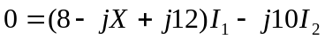 (1)

For mesh 2,
(2)

Substituting (2) into (1) leads to
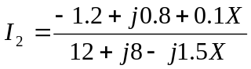

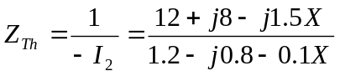

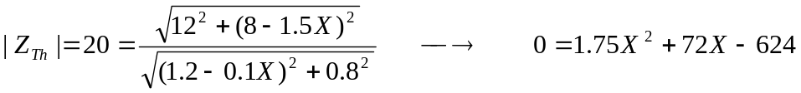

Solving the quadratic equation yields X = 6.425 Ω

